## Story ID 6: Daily Summary of Deliveries

User Story: As the driver I want to be able to see a daily summary of the packages I have to deliver and be able to sort them so that I can work at maximum efficiency and plan my day.

* Logging on as a Driver, I can access the Shifts and Timetable page from my dashboard sidebar.

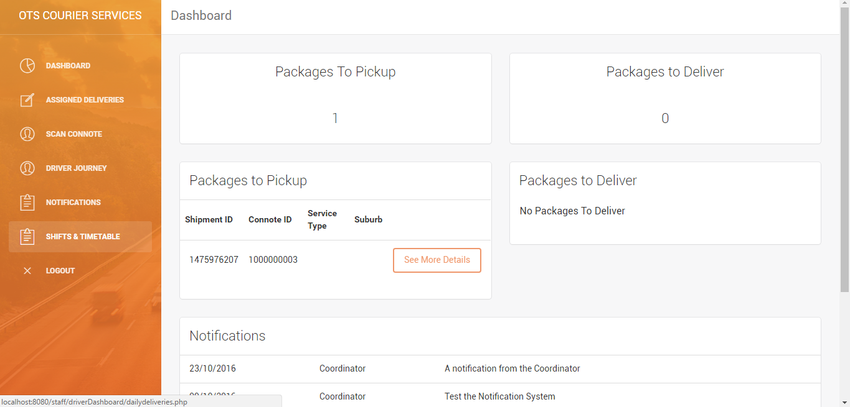

* On the Timetables page, I'm given a daily summary of every package I'm assigned to deliver that day. As there are no packages assigned for today, I can browse through coming days for packages.

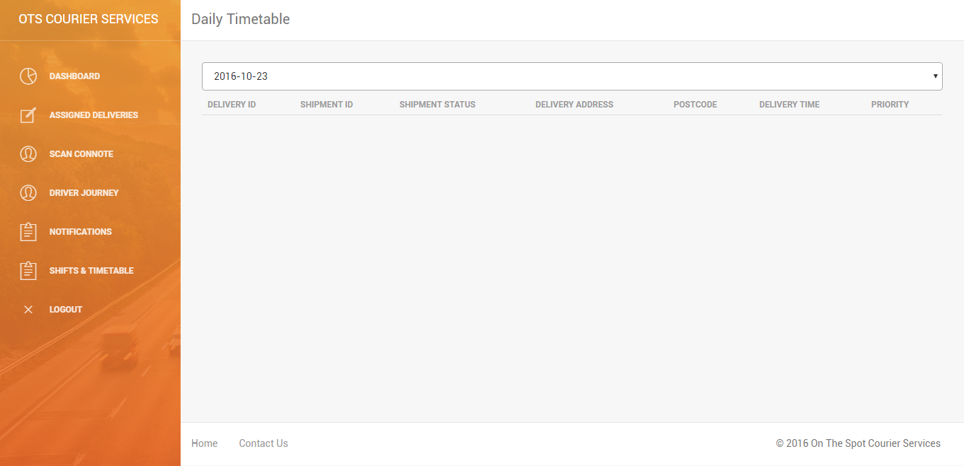

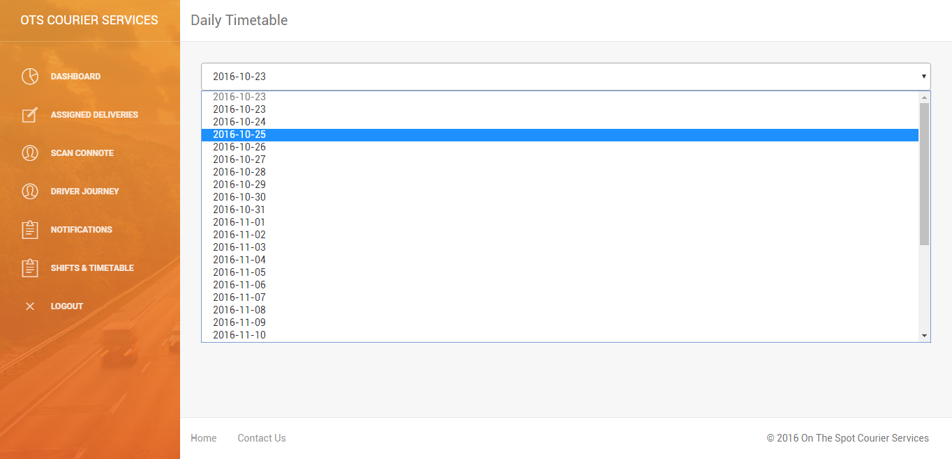

* I am able to select a future date, and view all the packages that I am to deliver on that date, arranged in order of delivery time.

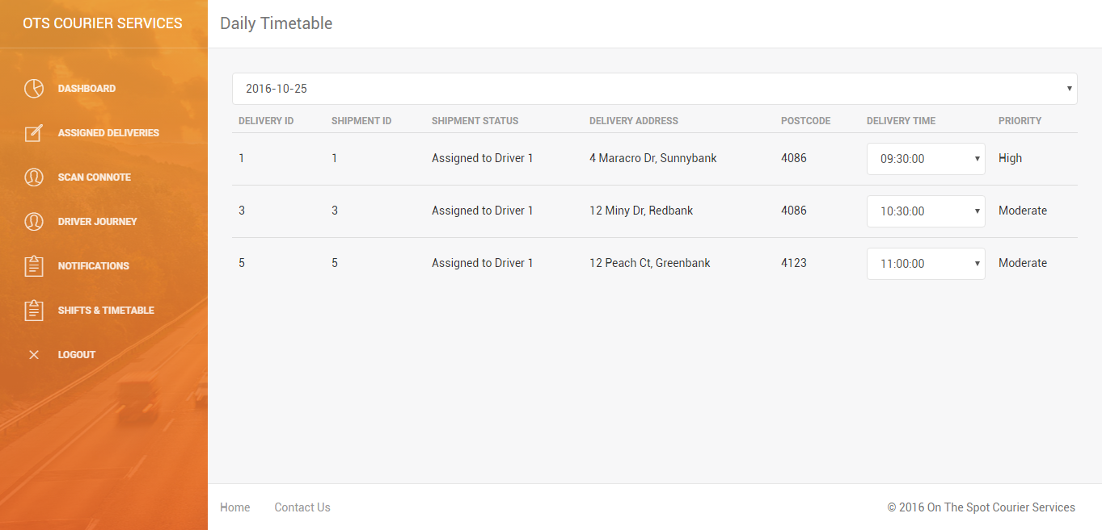

* I am to change the time I am scheduled to deliver the packages by clicking on the drop-down box and selecting a new time, anywhere from 6:00am to 4:00pm.

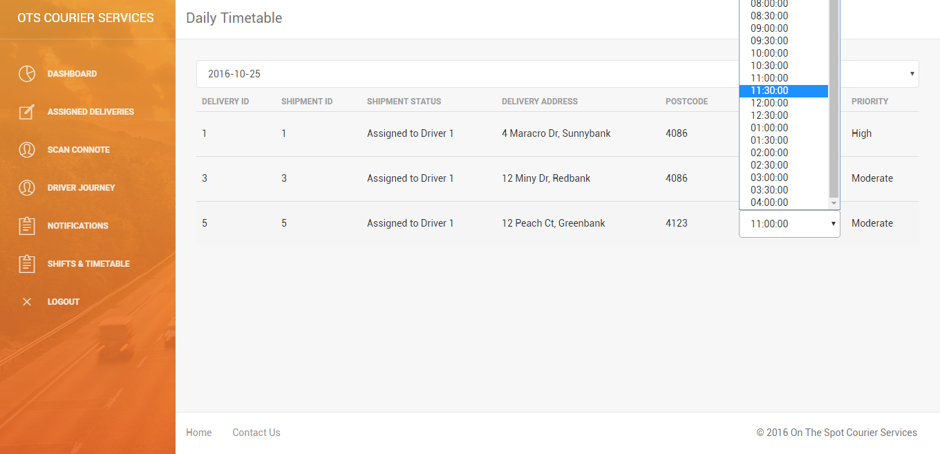

* Once a selection is made, the page updates with the new assigned time for delivery.

